# Assignment 5

FNU GAURAVDEEP SINGH

1001827248

CSE 5321-001

**Selected All Mutators:**

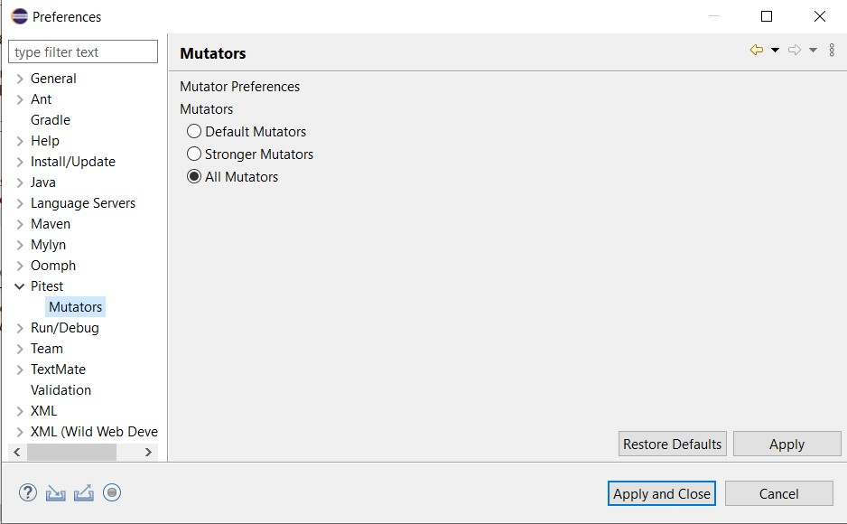

**Task 1:**

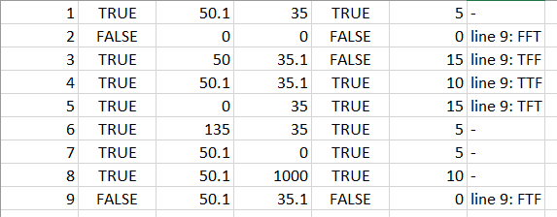

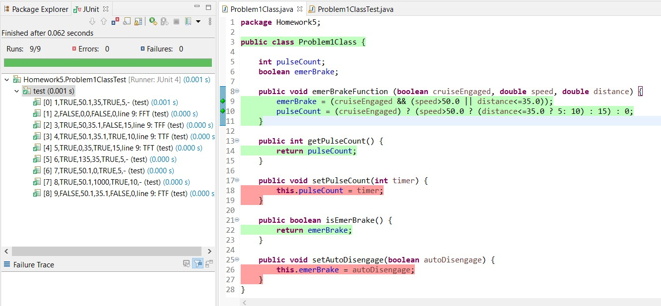

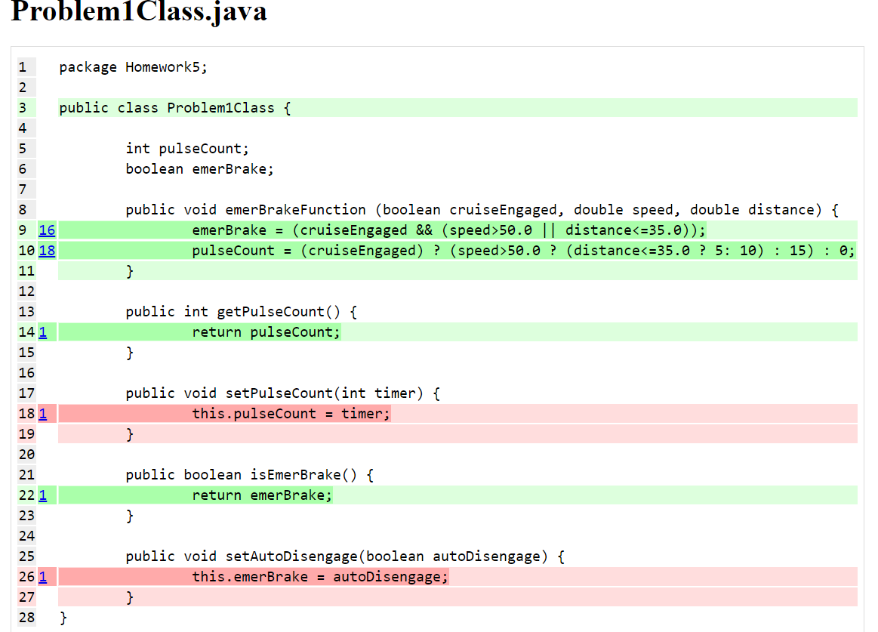

**Task 2:**

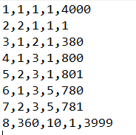

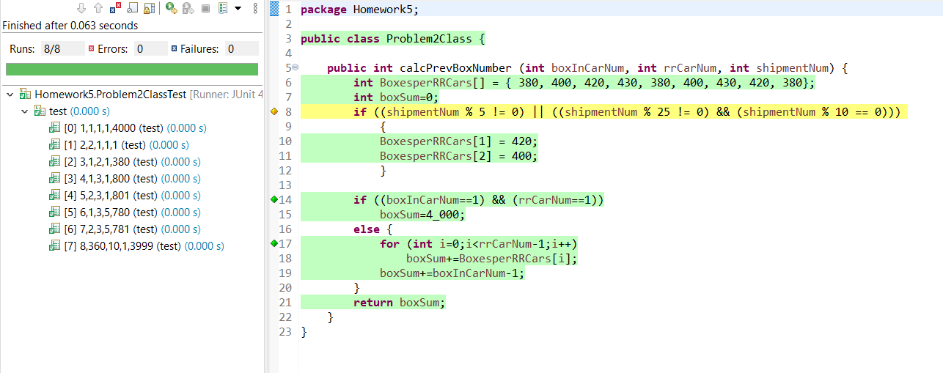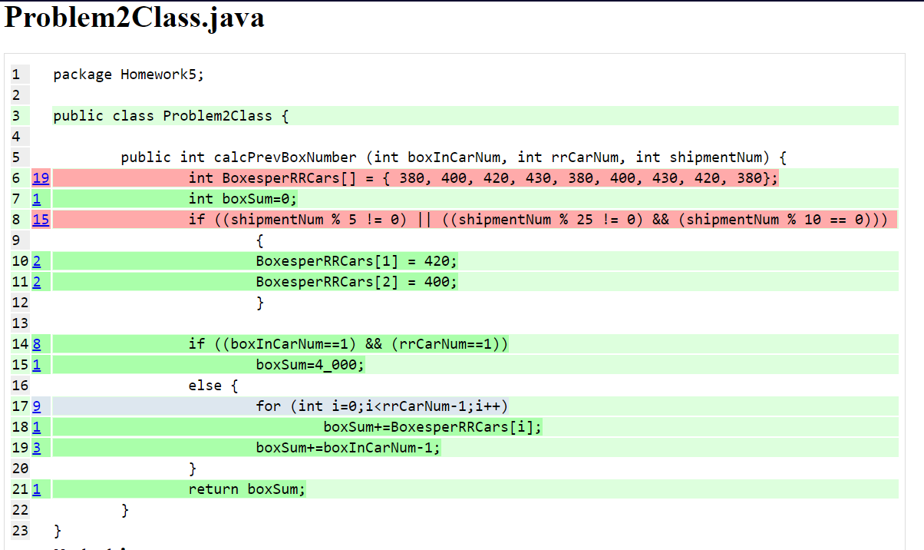

**Task 3:**

**Corrections**:

Line 22: Changed X=3 to X=2

Line 25: Changed state.L to state.OFF

Line 27, Changed X=2 to X=1

Line 28, Changed B==1 to P==1

Line 29, Changed state.U to state.X5

Line 34, Changed T to I (2 T’s)

Line 35, Changed P==1 to Z==1

Line 36, Changed state.OFF to state.U

Line 36, Changed T to I (2 T’s)

Line 42, Changed T to I (2 T’s)

Line 46, Changed I to T (2 I’s)

Added **break** after all switch cases.

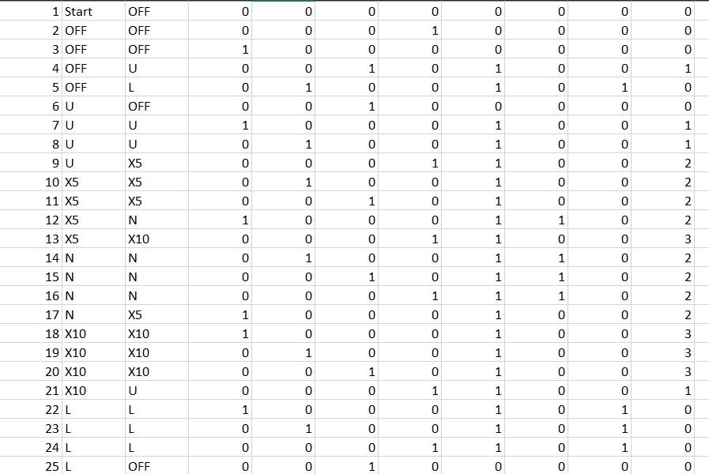

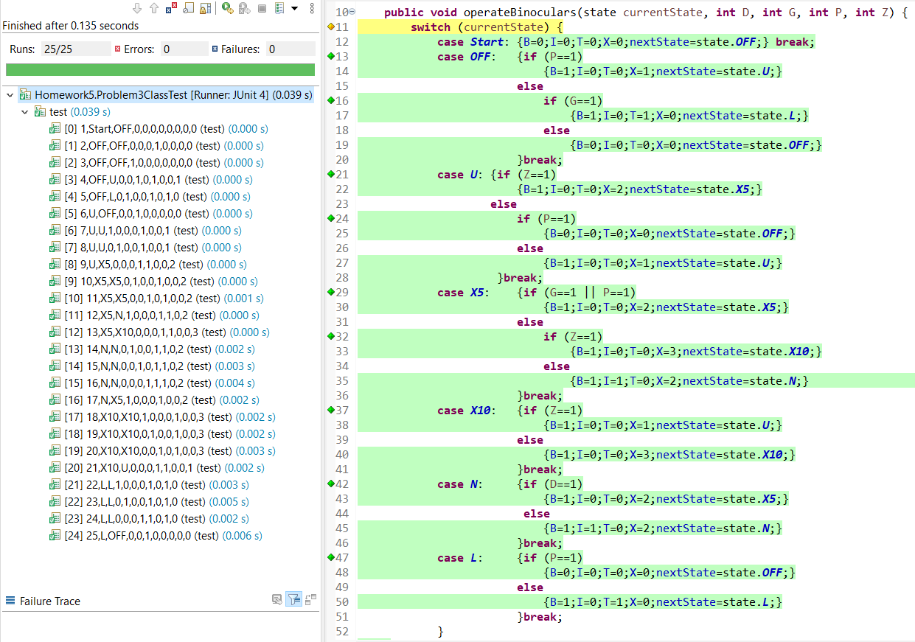

**Task 4:**

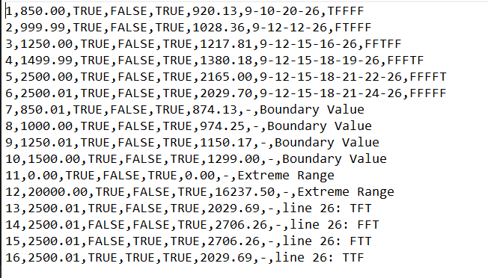

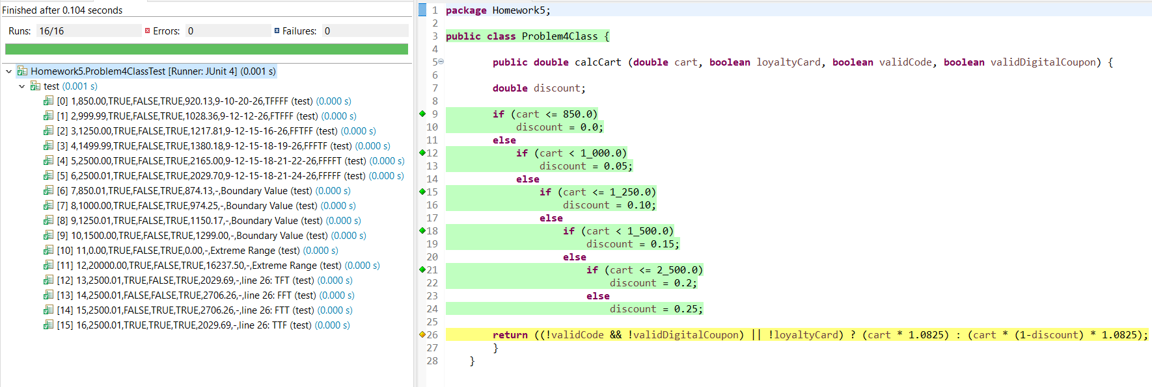

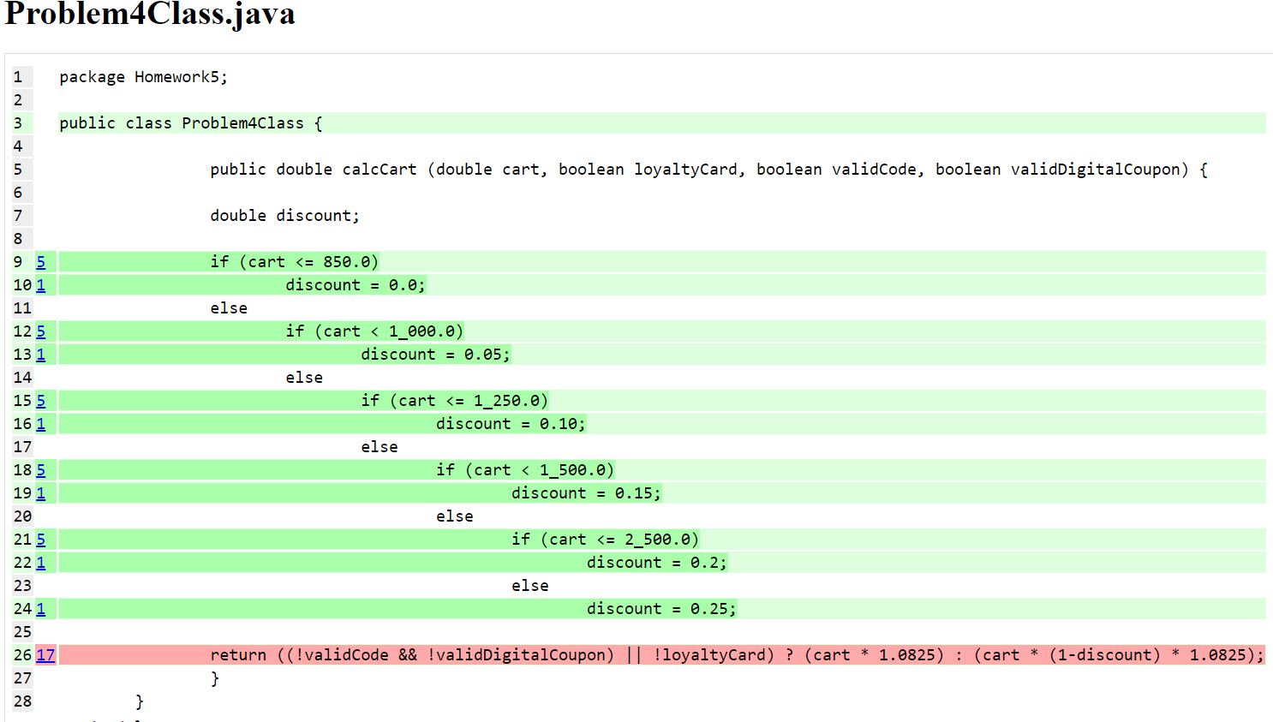

**Task 5:**

